A URL Shorterner
by
TAN Xingzhi
3036532736

Dissertation midterm report
2025/2026 Sem 2

Master of Engineering
In
EEE
of
The University of Hong Kong

目录
1. Project Overview 4
1.1 Background 4
1.2 Project objectives 5
1.3 Original research question 5

Project Overview

Background
URL shorteners are online services or web tools that convert lengthy Uniform Resource Locators (URLs) into short, memorable URLs. This reduces the complexity of remembering and typing for users and facilitates sharing in contexts with character limits, such as social media and SMS. The core function of shortened links is to reduce the number of characters in the original URL to improve dissemination efficiency; its principles include URL mapping mechanisms and HTTP redirection technology.
The core value of shortened link services lies not only in improving link readability and user experience but also in their powerful data analysis and click tracking capabilities—providing data such as click volume, user geographic location, device type, and conversion rates to help businesses optimize marketing campaigns and analyse user behaviour. It has become deeply integrated into the digital business ecosystem.
The earliest URL shortening service can be traced back to TinyURL, launched in 2002 and developed by Kevin Gilbertson. Its predecessor dates to 2001. TinyURL's creation influenced the creation of at least 100 subsequent URL shortening services[1]. According to The New York Times, TinyURL, founded in 2002 by a unicycle enthusiast named Kevin Gilbertson, was the most popular URL shortening service. TinyURL later experienced rapid growth, storing approximately 293 million URLs in its database.
Modern enterprise-level short link services have long surpassed basic redirects, offering data tracking capabilities such as recording clicks, regions, devices, and source channels. They can generate dynamic links with UTM parameters; they also feature brand customization, allowing users to replace public domains with their own domains (e.g., s.companyname.com/event), enhancing company credibility and exposure, and increasing click-through rates by an average of 34%; in terms of security, they can block phishing/spam websites and prevent links from being blocked; they support link expiration dates, password access, and single-use validity; and they have dynamic adjustment capabilities—if printed materials have already been sent and the original link is found to be invalid, the target URL pointed to by the short link can be modified in the backend, eliminating the need to reprint materials.

Project objectives
Build a fully functional short link generation and management platform, providing features such as custom short codes, access statistics, expiration control, and QR code generation, while also having the ability to analyze multiple types of click data.
- Implements user registration, login, and password reset authentication functions.
- Supports shortening long URLs to system-generated or user-defined short codes.
- Records detailed data for each short link access (IP, User-Agent, Referer).
- Provides flexible expiration time settings (1 day/7 days/30 days/permanent) and custom expiration conditions.
- Generates a QR code for each short link and supports downloading.
- Supports user management of their generated short codes. Provides short link access data analysis and visualization, generating analysis reports for user-generated short code click data.
- User-friendly interface

Original research question
- How to design a lightweight, efficient, secure, and stable URL shortener to achieve fast compression and accurate redirection of long URLs, while addressing the core pain points of traditional shorteners such as redirection delays and broken links?
- Regarding the uniqueness conflicts and data security issues during URL shortening, what encoding algorithms and storage schemes should be adopted to ensure the uniqueness of the shortened URL while protecting user privacy and link security?
- How to add practical extended functions to the URL shortener (such as access statistics, expiration management, and custom shortening codes) to improve product usability and meet the actual needs of individuals and small teams?

2.1 Progress Update
- User Authentication & Account Management
- User Registration: New users can create an account by providing a unique username, email, and password (minimum 6 characters). Passwords are securely hashed using generate_password_hash.
- User Login: Authentication supports both username and email as identifiers. Session management is implemented using Flask's signed cookies.
- Password Reset Flow: A complete "forgot password" workflow is in place. A UUID-based reset token with a 1-hour expiry is generated and stored in the database. The reset link is displayed in the server console (simulating email delivery for demonstration purposes).
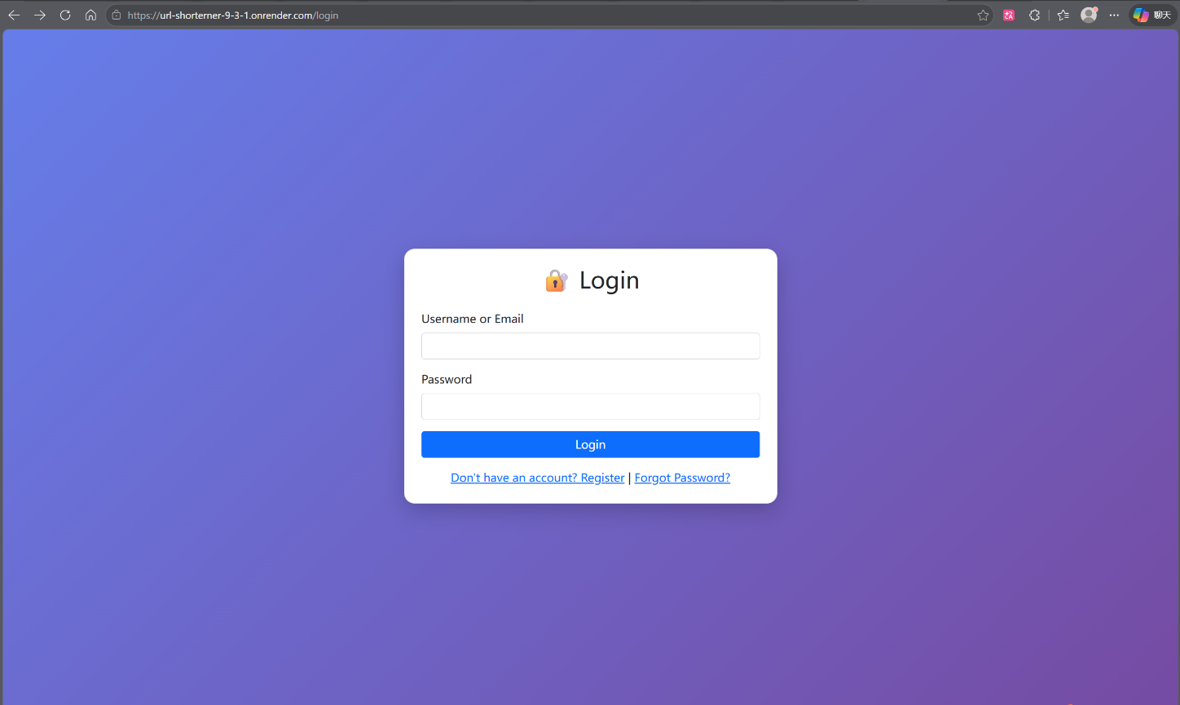
- Logout: Session clearance and redirection to the login page.

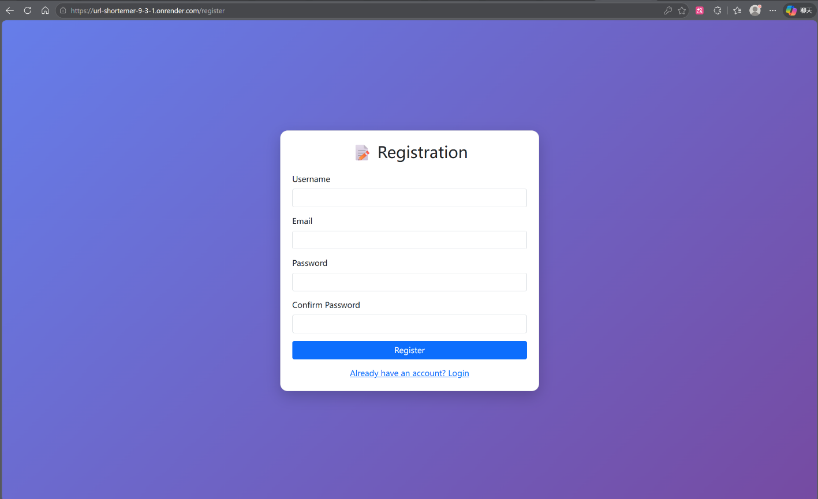
- URL Shortening Core Engine
- Long URL Submission: Users submit a target URL. The system automatically prepends https:// if no scheme is provided.
- Random Short Code Generation: When no custom code is requested, the system generates a 6-character alphanumeric code using a cryptographically secure random selection (random.choice). The generator checks for collisions and reserved words, retrying up to 10 times before failing gracefully.
- Custom Short Code Support: Users may specify a vanity short code. The system enforces strict validation rules:
- Length: 3–20 characters.
- Allowed characters: a-z, A-Z, 0-9, _, -.
- No leading/trailing hyphens or consecutive hyphens.
- Prohibited use of reserved system paths (e.g., admin, api, login).
- Duplicate Prevention: The system verifies the uniqueness of any custom code against the database before insertion.

- Expiration & Lifecycle Management
- Configurable Expiry: Users may select an expiration period for each shortened link: 1 day, 7 days, 30 days, or "Permanent".
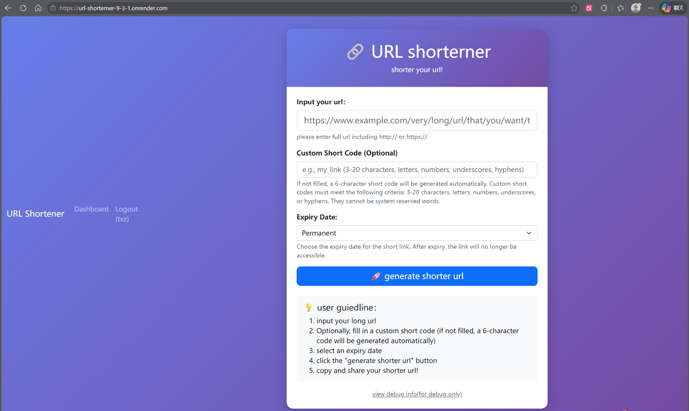
- Expiry Enforcement: During redirection, the system compares the current timestamp against the stored expires_at value. Expired links return an HTTP 410 (Gone) error page.
- Redirection & Click Analytics
- HTTP 302 Redirect: Accessing a valid short code (/<short_code>) seamlessly redirects the user's browser to the original long URL.
- Real-time Click Counter: Each redirect increments the click_count field in the url_mappings table.
- Detailed Click Logging: The following metadata is recorded in the clicks table for every access:
- IP Address: Extracted from X-Forwarded-For header (to support proxy deployments like Render) or request.remote_addr.
- User-Agent: The full browser/client identifier.
- Referer: The HTTP referrer, if available.
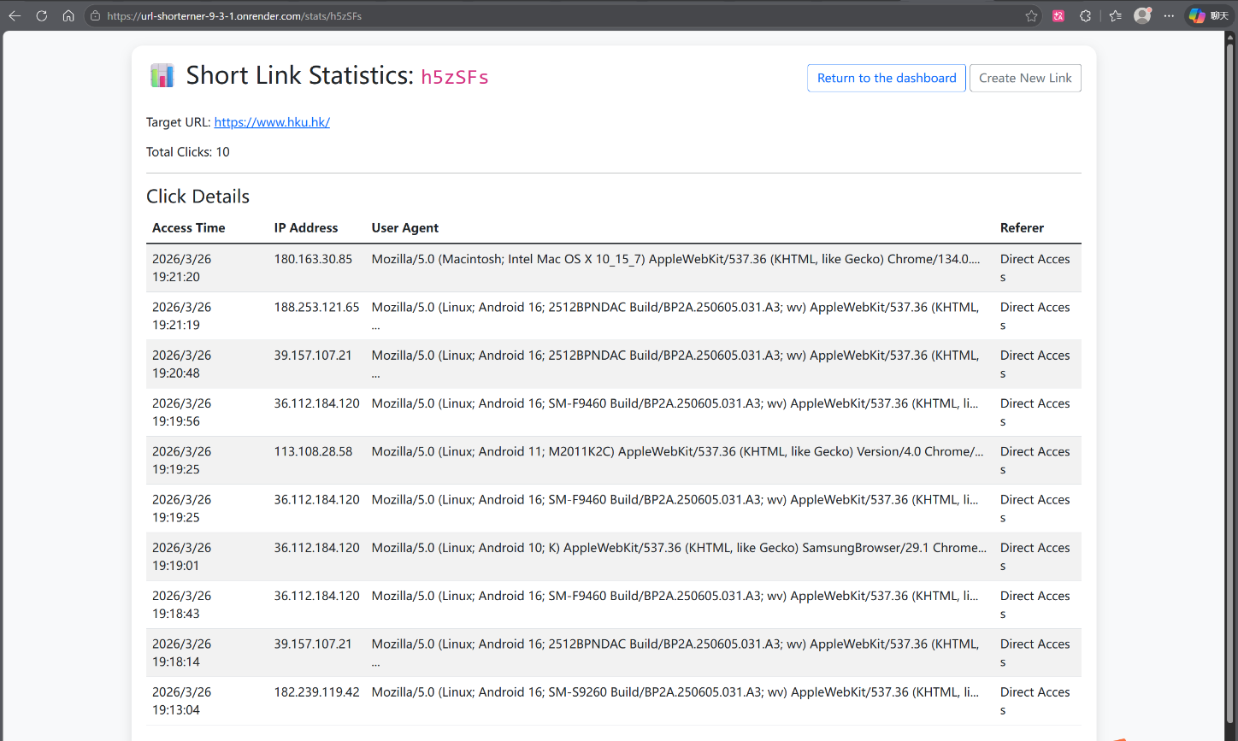
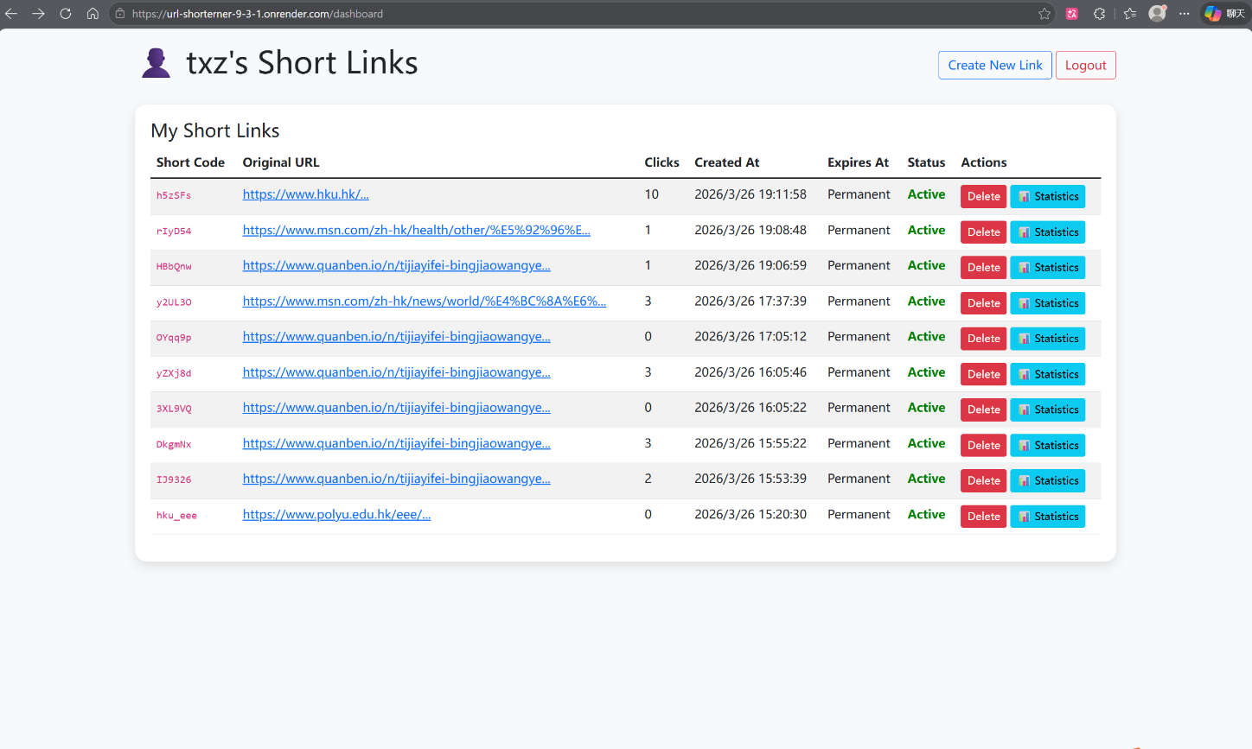
- Timestamp: Exact date and time of access.

[1]The New York Times. "Mini-Links to Web Sites Are Multiplying." May 4, 2009.

